User Manual: Waypoint

Te ora te hoк tere – life is a journey. **Waypoint** is designed for people in all walks of life looking to engage in physical activities. Challenge yourself with activities set by others, or create your own! Share your experiences and learn the best places to go from those who have been there, done that.

Table of Contents

Quick Start Guide 3

Admin Controls 4

User Accounts 4

Activities 4

Signing Up 5

Requirements 5

Special Fields 5

Passport Countries 5

Activity Types 5

Logging In 5

Editing Your Profile 6

General Info 6

Photo 6

Passport Countries 6

Add a Passport 6

Remove a Passport 6

Emails 7

Add an Email 7

Delete an Email 7

Change Primary Email 7

Location 7

Activity Types 7

Add an Activity Type 7

Delete an Activity Type 7

Account 8

Change Your Password 8

Deleting Your Account 8

Searching for Other Users 9

Filters 9

Home Feed and Activity Roles 10

Activity Followers or Participants 10

Activity Organisers 10

Activity Creators 10

Activities 11

Viewing Your Activities 11

Creating an Activity 11

Requirements 11

Editing an Activity 12

Adding Photos to an Activity 12

Deleting Photos from an Activity 12

Deleting an Activity 12

Searching for an Activity 13

Activity Visibility and Sharing 13

# Quick Start Guide

Welcome to Waypoint! Here are a few steps to help you quickly get started:

1. Click on the “Sign up” button at the top right corner of the page.  
   
2. Fill out your details. Required fields are marked with a *  
   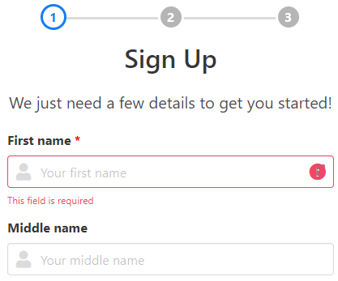
3. Hit the submit button at the bottom of the third page, and now you are ready to go!

When you log in, you will be taken to your home feed. Here, any updates to activities you are involved with will be displayed. The navigation bar at the top of the page has some handy buttons to help you navigate around the website.



“My Profile” will take you to your profile page, where you can see your details, and any activities you are involved in. To edit your profile, click the “Edit Profile” button in the navigation bar where the “My Profile” button used to be. All fields are modifiable, and all non-mandatory fields can be deleted.

To look for other registered users, clicking “Search Users” will take you to the user search page. Clicking “Search” will retrieve the users which match your search filters – if you have not entered any filters, no users will be retrieved. Double clicking on a search result will take you to the corresponding user’s profile. For activity types, “any of” will find users who have one or more of the types on their profile, and “all of” will find users which have all the types.

Clicking “Search Activities” will take you to the activity search page. A range of different search filters can be applied – the basic form of searching is done by name, but hashtags, activity types, date range, and location bounds may be specified. If no filters are applied, no activities will be retrieved. When viewing an activity, clicking follow or participate will subscribe you to any updates from that activity. These updates will be displayed in your home feed.

# Admin Controls

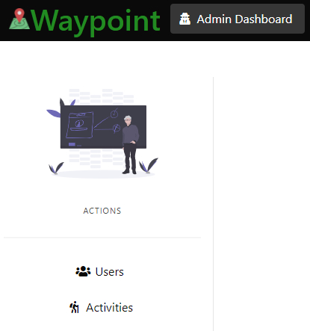Waypoint comes with an automatically generated global admin account which cannot be deleted. This ensures that if all other admin accounts are deleted or have their admin privileges revoked, there will always be an account through which the admin-only features can be accessed.

Logging in as an administrator will give you access to the admin dashboard, where you can access controls such as editing and deleting other users’ accounts, and granting / revoking admin privileges. It may be accessed by clicking the “Admin Dashboard” button in the top left corner. Apart from the global admin account (which does not have a profile and hence cannot edit it), admin accounts are able to use all the features of Waypoint as if they were an ordinary user. To reflect that the user is logged in as an admin, the navigation bar at the top of the page changes to a dark colour shceme.

## User Accounts

The admin controls for interacting with user accounts are only accessible through the user search in the admin dashboard – not the ordinary search page. The options become visible when the ellipsis next to the information icon is clicked.

Clicking “Edit” will allow the admin to edit a user’s account as if they were the user editing their own account.

Clicking “Grant Admin” will open a prompt to ask the admin to confirm they would like to grant the user admin privileges. If the user is already an admin, the button will change to say “Revoke Admin” and will revoke the user’s admin privileges when the prompt is confirmed.

Clicking “Delete” will open a prompt to ask the admin to confirm they would like to delete the user’s account.

## Activities

Admins can modify and delete activities created by users, and can control user roles within the activity. However, admins cannot modify the creator of an activity. These actions are done through the activity’s page, rather than the admin dashboard.

# Signing Up

To sign up, click on the “Sign up” button in the top right corner – this will open the registration page. Successfully signing up will automatically log the new user in, and redirect them to their home feed.

## Requirements

There are 7 required fields for registering:

* First name
* Last name
* Date of birth
* Gender
* Fitness Level (2nd page)
* Primary email
* Password

The first name, middle name, last name, and nickname fields all have a maximum length of 50 characters. The bio field is limited to 200 characters. Passwords must have a minimum of 8 characters.

The email field will only accept email addresses which match the format of an address. Only the primary email is required for the email section – additional emails are not mandatory. Users can have up to 5 email addresses associated with their account.

Your location may be entered by typing into the field, clicking on the map, or dragging the marker that appears on the map once clicked.

## Special Fields

### Passport Countries

A user may have passports from different countries associated with their profile. The Passport Countries field will suggest autocompletions which the user may select from.

### Activity Types

Like passport countries, the Activity Types field allows users to select the types of activities they enjoy, from a list of suggested autocompletions.

# Logging In

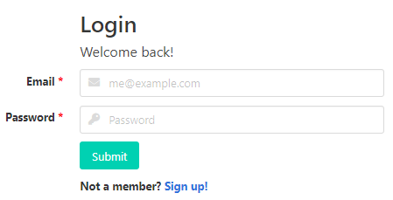Logging in requires a user to input their primary email address and their password into their respective fields.

The email field will only accept email addresses which match the format of an address. The password field will only accept input of 8 characters or more, as the minimum password length for all users is 8 characters. When both conditions are satisfied, Waypoint will attempt to log the user in.

# Editing Your Profile

Users may edit their own profile by clicking on the “Edit Profile” button in the top right corner, next to the log out button. This button takes the place of the “My Profile” button while viewing your own profile page.

There are a number of different tabs categorising the fields within a user’s profile.

## General Info

The “General” tab allows users to modify their name, nickname, date of birth, gender, fitness level, and bio. All non-mandatory fields may be modified and cleared, whereas mandatory fields may only be modified.

The mandatory fields within the general tab are:

* First name
* Last name
* Date of birth
* Gender
* Fitness level

The first name, middle name, last name, and nickname fields all have a maximum length of 50 characters. The bio field is limited to 200 characters.

## Photo

The “Photo” tab allows users to upload or remove their profile or cover photo.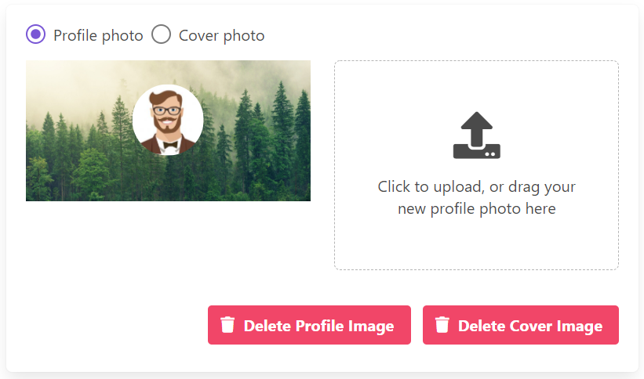

## Passport Countries

The “Passport” tab allows users to add and delete the passports associated with their account.

### Add a Passport

1. Click the dropdown list
2. Select the country you would like to add
3. Click “Add Country”
4. Click “Save Passports” to save the change(s)

### Remove a Passport

1. Click the red x next to the passport country you would like to remove from your account
2. Click “OK” to confirm the change
3. Click “Save Passports” to save the change(s)

## Emails

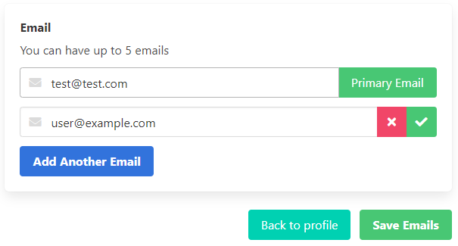The “Emails” tab allows users to add and delete emails associated with their account, and change their primary email.

### Add an Email

1. Click “Add Another Email” to reveal another email field if there are not already 5 email fields
2. Fill in the blank email field with the new email address
3. Click “Save Emails” to save your changes

### Delete an Email

1. Click the red x on the email address you would like to delete. If you want to delete your primary email address, you will have to select a different email to be the primary address first.
2. Click “OK” to confirm the change
3. Click “Save Emails” to save your change(s)

### Change Primary Email

1. Click the green tick next to the email address you would like to make the primary email address
2. Click “OK” to confirm the change
3. 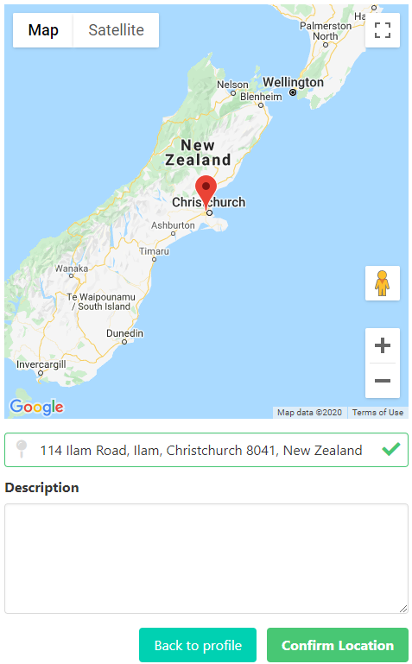Click “Save Emails” to save your change(s)

## Location

The “Location” tab allows users to modify their location in the same way as the sign-up page. Location may be input in the text field, by clicking a point on the map, or dragging the marker that appears on the map once it has been clicked. As the field is non-mandatory, users can delete their location.

Additionally, a description can be input to better describe your specified location. For example, you may wish to specify that when on the gravel road, visitors should turn right at the junction with the large oak tree.

## Activity Types

The “Activity Types” tab allows users to add and delete activity types associated with their profile.

### Add an Activity Type

1. 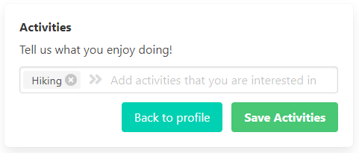Begin typing an activity in the text field
2. Click one of the suggested autocompletions
3. Click “Save Activities” to save your change(s)

### Delete an Activity Type

1. Click the grey x to the right of the activity type you would like to delete
2. Click “Save Activities” to save your change(s)

## Account

The “Account” tab allows users to change their password, or delete their account. New passwords must have a minimum of 8 characters.

### Change Your Password

1. Enter your current password into the “Current password” field
2. Enter the new password of at least 8 characters into the “New password” field, and repeat the new password in the “Confirm new password” field
3. Click “Change Password” to save the change

### Deleting Your Account

This action cannot be undone! To delete your account, click “Delete Account” and click “Delete” in the pop up to confirm.

# Searching for Other Users

Searching for other users can be done on the search page, accessed by clicking “Search Users” in the top right corner. You must be logged in to access this page. Clicking the “Search” button in the filters section will retrieve users matching the filter(s), if any. If no filters are applied, no users will be returned. The search results will be displayed in a table, and double clicking on a search result will take you to the corresponding user’s profile. If there are too many results to fit on one page, click the arrows at the bottom of the table to move between the result pages.

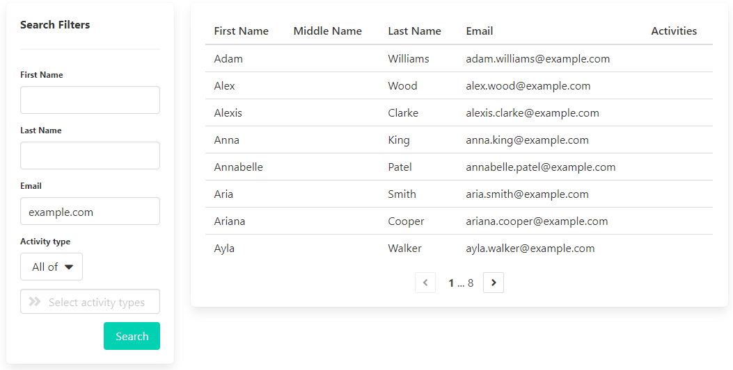

## Filters

* First name – case insensitive
* Last name – case insensitive
* Email
* Activity type(s) – select one or more activity type from the suggested autocompletions to search for users who have that activity type on their profile. Selecting “All of” from the dropdown will search for users who like all the selected activity types – e.g. someone who likes both skiing and hiking. Selecting “Any of” will search for users with at least one of the selected activity types – e.g. someone who likes skiing or hiking, or both.

# Home Feed and Activity Roles

Your home feed displays any updates to activities which you are involved in. A user may only have at most one role in an activity at any given time.

## Activity Followers or Participants

Following or participating in an activity will subscribe you to it, causing the activity’s updates to appear in your home feed.

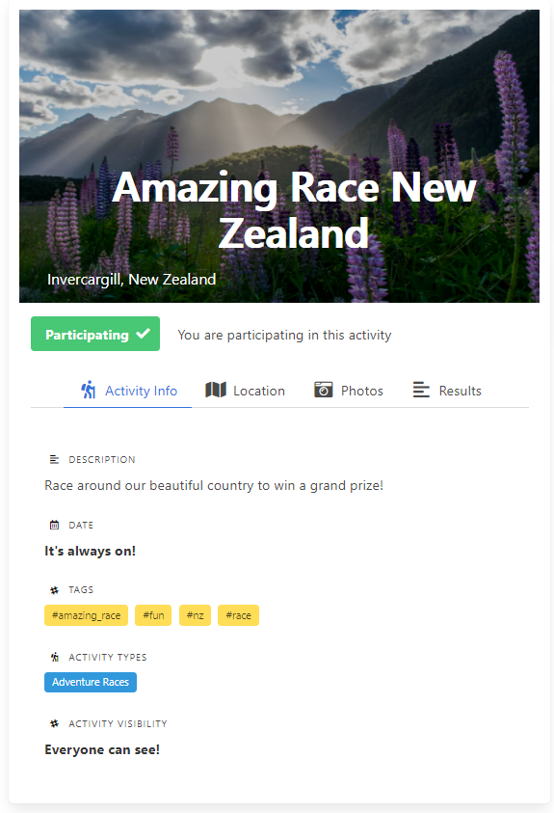Participating in an activity will allow you to add the results of your participation. The fields to be filled out depend on the fields specified by the activity creator. For specific details regarding the custom fields, see activity creation.

## Activity Organisers

The creator of an activity, as well as admins, can select users to be organisers for their activity. This gives the user the ability to modify the activity and manage users’ roles in the activity. This does not include the ability to delete or share the activity. Being an organiser will subscribe the user to the activity, and cause updates to appear in the user’s home feed.

## Activity Creators

The creator of an activity is unable to change their role. Creators have complete control over an activity – they can modify and delete the activity, share it, and control user roles within the activity.

To promote users to organisers of an activity, the user must first register themselves as a participant in the activity. From there, the creator should click “View All” in the Participants section, select the user they wish to promote, and click promote. Similarly, for demoting users from organiser to participant, the creator should click “View All” in the Organisers section, select the user they wish to demote, and click demote.

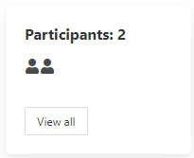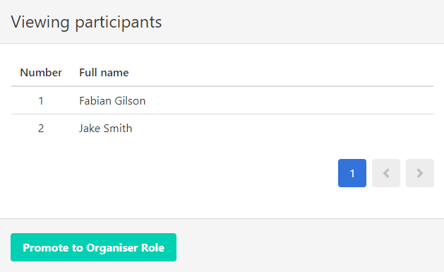

# Activities

Activities are events involving activity types that get created by users of Waypoint. They can be ongoing (continuous) or over a set period.

## Viewing Your Activities

Activities you are involved with can be found on your profile under the “Activities” tab. The switch toggles between viewing continuous activities, and those which are over a set time.

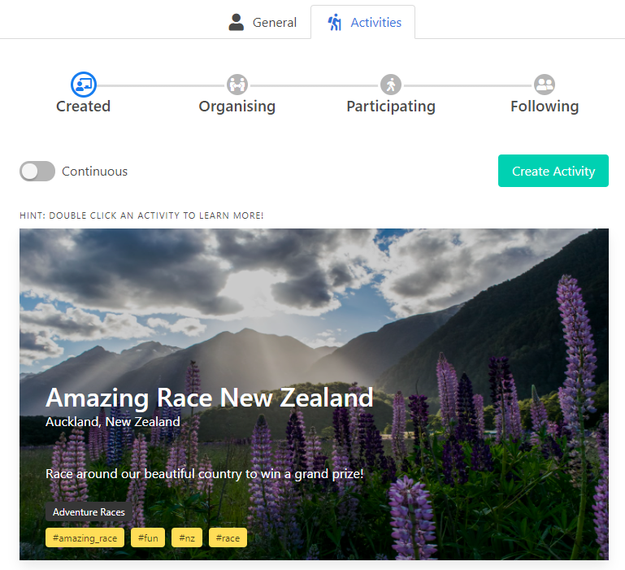

## Creating an Activity

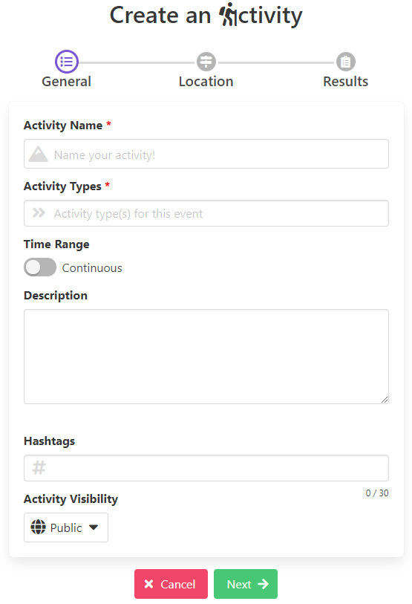To create an activity, navigate to the “Activities” tab on your profile page, and click the “Create Activity” button. Once all required details have been entered into the relevant tabs, click “Submit” to create the activity!

### Requirements

There are 4 required fields regardless of time range for an activity:

* Activity name
* Activity type(s)
* Location
* Visibility

Visibility for an activity consists of 3 options – public, restricted, or private. This changes who can view the activity once it has been created. Public activities can be viewed by any users. Restricted activities are only visible to a select few users, specified via email address. Private activities can only be seen by their creator.

The description has a maximum of 600 characters.

If the activity is set to be over a duration, the start and end dates are required. The start date must be the current date or in the future, and the end date must be either the same as the start date, or in the future.

If the activity is set to duration with a start/end time, the start/end times are required. If the end date is on the same day as the start date, the end time must be at least one hour after the start time. If start/end time is disabled, the activity will start when the activity is created and end one hour after.

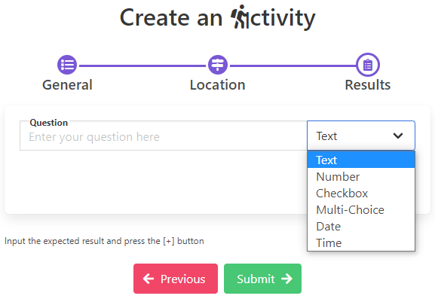Activities can have up to 30 unique hashtags associated with them. To add a hashtag, type it into the field and press enter. Hashtags are case insensitive, and cannot contain spaces or non-alphanumeric characters. Any spaces between alphanumeric characters will be replaced with underscores.

For activities which may have results, you can customise the fields a participant will fill out. Each field may be a text field, number field, checkbox, multi-choice option, date field, or a time field. The question field allows you to outline the desired input for the field (e.g. a question may be “Checkpoints reached” for a numeric field).

## Editing an Activity

To edit an activity you have created, view the activity and click the “Edit” button. All fields may be modified, and non-mandatory fields may be cleared. However, the activity result fields may only be modified if no one has yet added results to the activity. Fields must still conform to the requirements outlined in the creating an activity section. To save any changes, click “Submit.”

## Adding Photos to an Activity

Adding photos can only be done by the activity creator or organisers. To add photos to an activity, view the activity, navigate to the “Photos” tab, and click “Upload Images”. Images have a maximum size of 5mb.

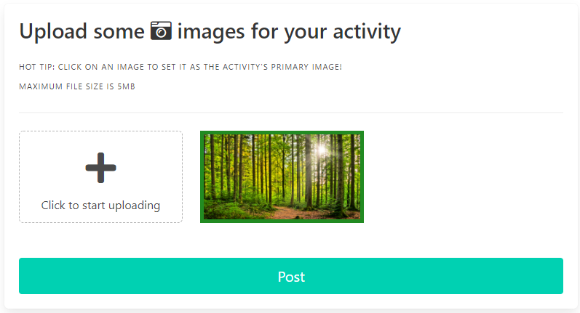Should an image not fit within the permitted dimensions, a cropping panel will appear for the user to specify how they want the photo to be displayed.

The primary image for an activity may be specified by clicking on the uploaded image’s preview. The primary image will be visually indicated by having a green outline.

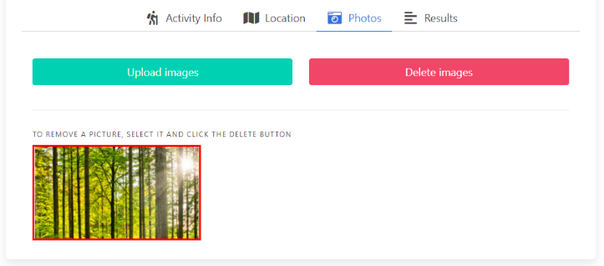To remove an uploaded photo, hovering over the image preview will reveal a red ‘x’ button which, when clicked, will remove the image.

## Deleting Photos from an Activity

Deleting photos from an activity can only be done by the activity creator or organisers. To do so, navigate to the activity’s “Photos” tab, select the image you wish to remove, and click “Delete images”.

## Deleting an Activity

To delete an activity you have created, navigate to the “Activities” tab on your profile page, and click the “Delete” button next to the activity you would like to delete. A prompt will open to request confirmation, and clicking “Delete Activity” will proceed to delete the activity.

## Searching for an Activity

Activities can be searched for by several filters on the Search Activities page, accessible by clicking “Search Activities”. The primary method of searching is by name. Additionally, any number of case insensitive hashtags may be input, and the matching criteria may be specified. Selecting “Any of” will find activities which contain at least one of the specified hashtags, whereas selecting “All of” will find activities which have all the specified hashtags. This behaviour is the same as with the activity types field. Results may be filtered to those which would appear within the map pane’s current viewing area.

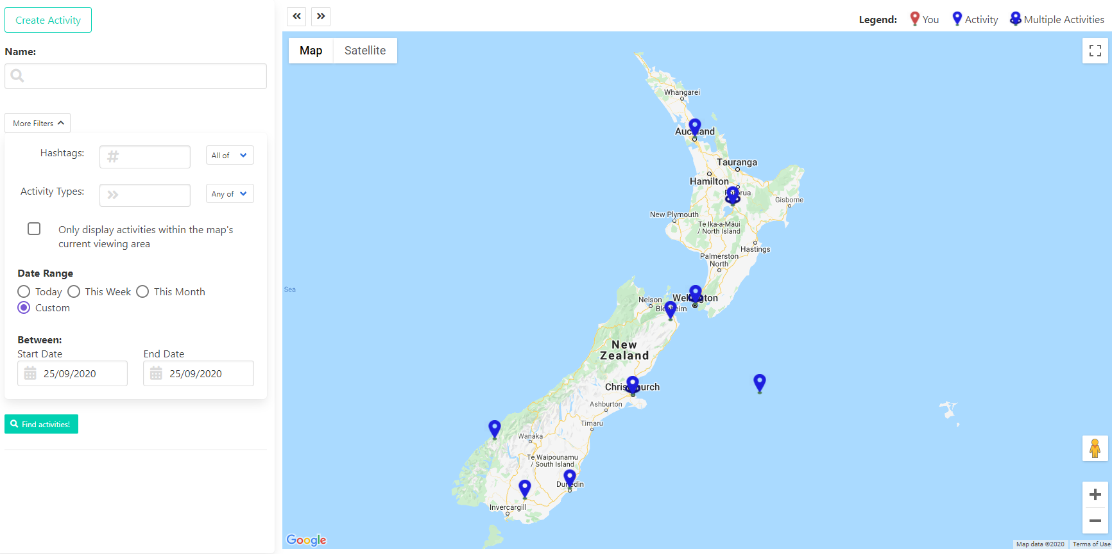

## Activity Visibility and Sharing

The visibility of an activity can be set depending on the creator’s preference. There are 3 tiers of visibility:

* Public: can be seen by any user in Waypoint
* Restricted: can only be seen by specific users whom the activity creator has specified via email address
* Private: can only be seen by the creator

Admins can see all activities regardless of the activity’s visibility setting.